**Project Design Phase-II**

**Data Flow Diagram & User Stories**

|  |  |
| --- | --- |
| Date | 27 june 2025 |
| Team ID | LTVIP2025TMID31891 |
| Project Name | **Sustainable Smart City Assistant** |
| Maximum Mark | 4 Marks |

**Data Flow Diagrams:**

**A sustainable smart city assistant connects people, data, and technology to promote greener, more efficient living. It gathers information from citizens, sensors, and policies—analyzes it—and delivers useful insights, eco-friendly tips, and city services in real time. Simple, smart, and sustainably aligned.**

* + **User interactions are managed through a conversational interface. Real-time data from sensors and APIs is aggregated and cleaned.**
  + **Analytics predict resource usage and detect anomalies.**
  + **Policy documents are summarized into digestible insights.**
  + **Recommendations are generated for citizens and planners.**

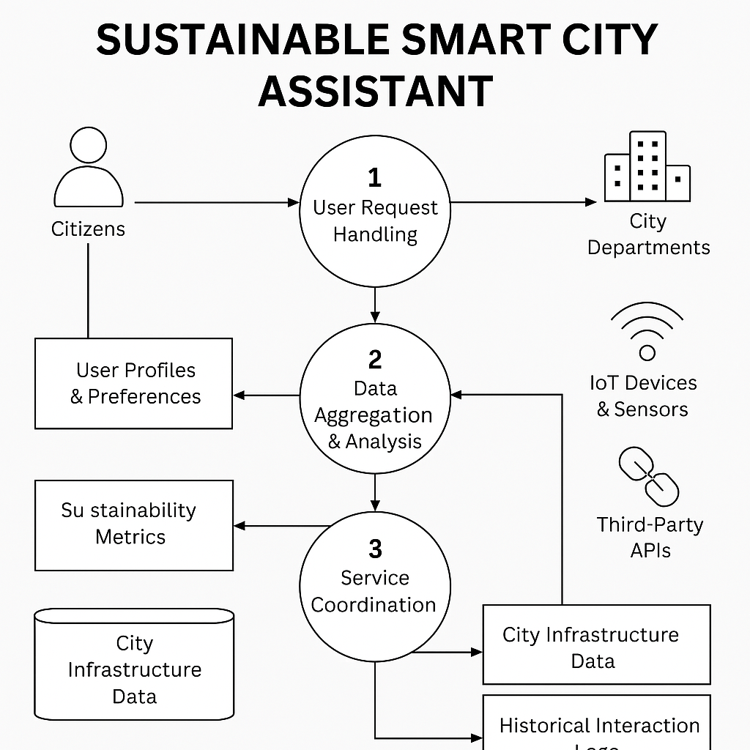

**User Stories**

**user stories** for a Sustainable Smart City Assistant:

* **Citizens** want *helpful, everyday tools*—like eco-tips, real-time transit updates, and issue-reporting features—to make more sustainable choices and stay engaged with their city.
* **City Officials** need *data-driven insights* and *summarized feedback* to shape responsive policies and prioritize citizen needs effectively.
* **System Administrators** focus on *system reliability* and continuous improvement through monitoring and testing of AI models and sensor data.

| **User Type** | **Functional Requirement (Epic)** | **User Story Number** | **User Story / Task** | **Acceptance criteria** | **Priority** | **Release** |
| --- | --- | --- | --- | --- | --- | --- |
| citizen | Registration | USN-1 | As a resident, I want personalized eco-tips based on my habits | citizens believe the assistant improves their daily life or decision-making. | High | Sprint-1 |
|  |  | USN-2 | As a commuter, I want real-time transport and traffic updates | The system is intuitive and accessible to users of all digital skill levels. | High | Sprint-1 |
|  |  | USN-3 | As a concerned citizen, I want to report issues like leaks or dumping | Citizens feel their data is secure and the assistant is reliable. | Low | Sprint-2 |
|  |  | USN-4 | As a user, I can register for the application through Gmail |  | Medium | Sprint-1 |
|  | Login | USN-5 | As a user, I can log into the application by entering email & password |  | High | Sprint-1 |
|  | Dashboard |  |  |  |  |  |
| city officer |  |  | Supports local, state, and national sustainability goals and urban development plans. |  |  |  |
| Customer Care Executive |  |  | Provides actionable insights from real-time and historical data to inform planning. |  |  |  |
| Administrator |  |  |  |  |  |  |
|  |  |  |  |  |  |  |
|  |  |  |  |  |  |  |
|  |  |  |  |  |  |  |